**Wireless Innovation Grant**

**Guidance Notes**

**Introduction**

The River Severn Partnership Advanced Wireless Innovation Region is a £3.75m programme, wholly funded by the Department for Science, Innovation and Technology (DSIT) and managed by Shropshire Council on behalf of the River Severn Partnership (RSP).

The Programme aims to accelerate the adoption of technology enabled by Advanced Wireless Connectivity (AWC) to create opportunities for economic growth and generate efficiencies that have environmental, social and economic benefits.

The Programme is focused on three sectors which have particularly strong roots in the River Severn catchment area.

• Water Management

• Agriculture

• Public Sector

**The Wireless Innovation Grant**

Businesses and organisations within the River Severn Catchment that have been operating for more than a year in the three core sectors of water management, agriculture and the public sector (including Voluntary or Community Sector Enterprise (VCSE)) are invited to apply for up to £5,000 of grant funding to assist them to purchase and install wireless technologies at their business or organisational premises.

The aim of this intervention is to demonstrate to applicants and their peers the material impact that adopting relatively low-cost wireless technologies can have on their own and similar organisations.

|  |  |
| --- | --- |
| River Severn Catchment Area |  |

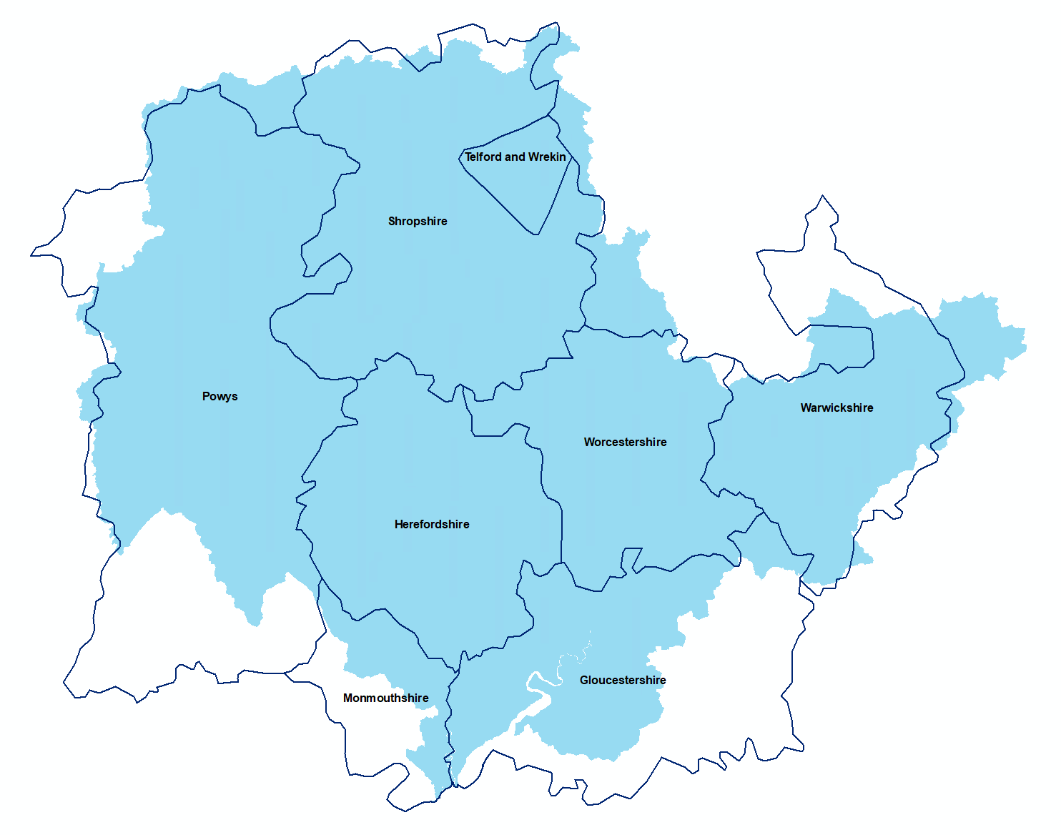

Applicants should consider where wireless technologies can be deployed that can enable multiple applications e.g., both asset management and environmental monitoring as ‘stackable’ uses can help to justify any ongoing costs and multiply the benefits.

**Available Funding**

Initially, £100,000 has been set aside for the Wireless Innovation Grant and this will be delegated on a first to qualify basis. The total pot available may be increased over time, depending on demand and on the availability of funding elsewhere in the RSPAWIR budget. However, there is no guarantee that extra funding will be available so applicants are advised to submit as early as possible to avoid disappointment.

The grant will be open to applicants between June and December 2024. The **closing date** will be 4pm on December 20th 2024.

**What can be covered**

The grant can be used to cover the costs of equipment, sensors, devices, software, subscriptions and licences, legal fees, installation, training and project management. If there are legitimate costs that sit out-side of these areas, please contact the RSPAWIR team to confirm whether they would be eligible.

Ordinarily, the grant will cover up to 75% of the total project costs. This can rise to 90% where the applicant is a VCSE.

Staff time, where clearly evidenced as contributing to the project e.g., undertaking the installation, negotiating with landlords or training to use the equipment, can account for a maximum of 10% of the costs but these will need to be evidenced with proof of salary, timesheets and, where applicable, attendance records.

Please note this is a small grant scheme and intended to support businesses and organisations to implement small scale wireless innovation projects. If what you are seeking to do is of a larger scale, contact the RSPAWIR team directly to see if there are other options where support may be available.

**How to apply**

Please complete the application form and send to [matt.smith@shropshire.gov.uk](mailto:matt.smith@shropshire.gov.uk)

Be as open and honest as you can. No one is trying to catch you out and if you are looking to invest time and energy in wireless technology then we really want to help. If you’re unsure on how to respond or need any help completing the form, don’t hesitate to contact the RSPAWIR team.

Perhaps the most important element of the application is to show how you think this will make a difference to your business/ organisation and how you will be able to show whether it has or not. Try to really focus on this area.

Applications will be appraised and applicants will be informed of the determination within 10 working days of receipt.

Should the application be rejected, the reasons for that rejection will be communicated clearly to the applicant. The appraisers’ decision is final. However, should any reasons for rejection be surmountable, applicants are free to re-apply once the specific issues have been addressed.

All external costs will need to be supported by 2 quotations (3 in the unlikely event that the costs exceed £25k). These can include screenshots from online retailers showing comparative items.

You are not obliged to accept the lowest quotation received, but the rationale behind your decision must be explained fully. If this is not fully explained or the rationale is not considered sound, then we may ask you revisit your quotes.

If there is a conflict of interest with any business providing quotes, we may not be able to support this cost, and this will be at our discretion. It is therefore strongly advised that you do not seek quotations from family members or linked businesses.

**How will it be appraised?**

The appraisers will check the following before deciding whether or not to approve your application;

* General Compliance – Do the business or organisation details tally with sources of public record?
* Geographical eligibility – Will the project be delivered within the River Severn Catchment area?
* Sector eligibility – Is the applicant operating in one of the three core sectors? If you don’t work explicitly in the eligible sectors, contact us first to see whether a case can be made.
* Costs and funding – Have the costs been well researched and backed up with multiple quotes? Are the full costs understood? Are any internal costs commensurate with and relatable to the project and can they be evidenced e.g. through timesheets, salary details and records of attendance?
* Deliverability – Are there any dependencies that might risk the project being delivered by December 2024?
* Measurability – Does the applicant understand how the impact of the technology can be measured and is there a realistic plan for doing so?
* Conflicts of interest or causes for concern – Do any responses to the declarations section give any cause for concern?

**What happens if you’re successful**

If the application is approved, a Grant Funding Agreement will be issued to you to sign via Adobe Sign. Once this is countersigned by Shropshire Council, you will be able to commence with your project.

A purchase order number will be sent to you following commencement and you will be able to invoice Shropshire Council quoting the PO Number at your convenience.

**General Terms and Conditions**

The application should be completed and/ or signed by the most appropriate senior person in the business or organisation.

All successful applicants agree to providing a testimonial regarding the new technology they have adopted in order to encourage others to follow in their footsteps.

All invoices must be received by December 31st 2024 or thereafter may not be payable.

Multiple invoices can be issued in stages up to the total value of the grant.

All invoices should be submitted to [matt.smith@shropshire.gov.uk](mailto:matt.smith@shropshire.gov.uk) along with evidence of receipted payments made reflected in account statements and / or timesheets and records of attendance.

Payments against invoices submitted without evidence of the relevant costs incurred may be delayed until such time as adequate evidence is provided.

Spend incurred prior to the approval date will not be eligible.

Please ensure you fill in the figure for grant and percentage of total costs before the signature.

Ensure you read and agree with all statements and sign in the appropriate places.

If any of the information you have supplied within this application is considered to be commercially sensitive, please state the question numbers within the application form and detail any supporting documentation.